EARLY PREDICTION FOR CHRONIC KIDNEY DISEASE DETECTION

ABSTRACT

* INTRODUCTION

OVERVIEW

PURPOSE

* PROBLEM DEFINITION & DESIGN THINKING

EMPATHY MAP

IDEATION& BRAINSTORMING MAP

* RESULT
* ADVANTAGE AND DISADVANTAGE
* APPLICATIONS
* CONCLUSION
* FUTURE SCOPE
* APPENDIX

SOURCE CODE

INTRODUCTION

OVERVIEW

The Chronic kidney disease dataset and doing the complete analysis on the same our main goal will be to predict whether an individual will have chronic kidney disease or not based on the data provided.

PURPOSE

The rationale for testing asymptomatic people for CKD is that earlier detection might allow for the implementation of therapeutic interventions and avoidance of inappropriate exposure to nephrotoxic agents, both of which may slow the progression of CKD to end stage kidney disease.

PROBLEM DEFINITION & DESIGN THINKING

EMPATHY MAP

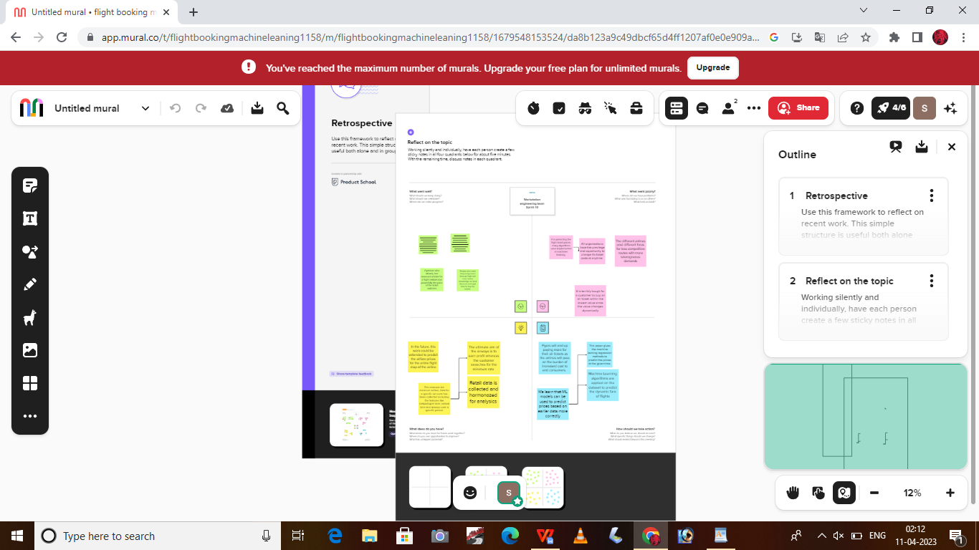

IDEATION & BRAINSTORMING MAP



RESULT

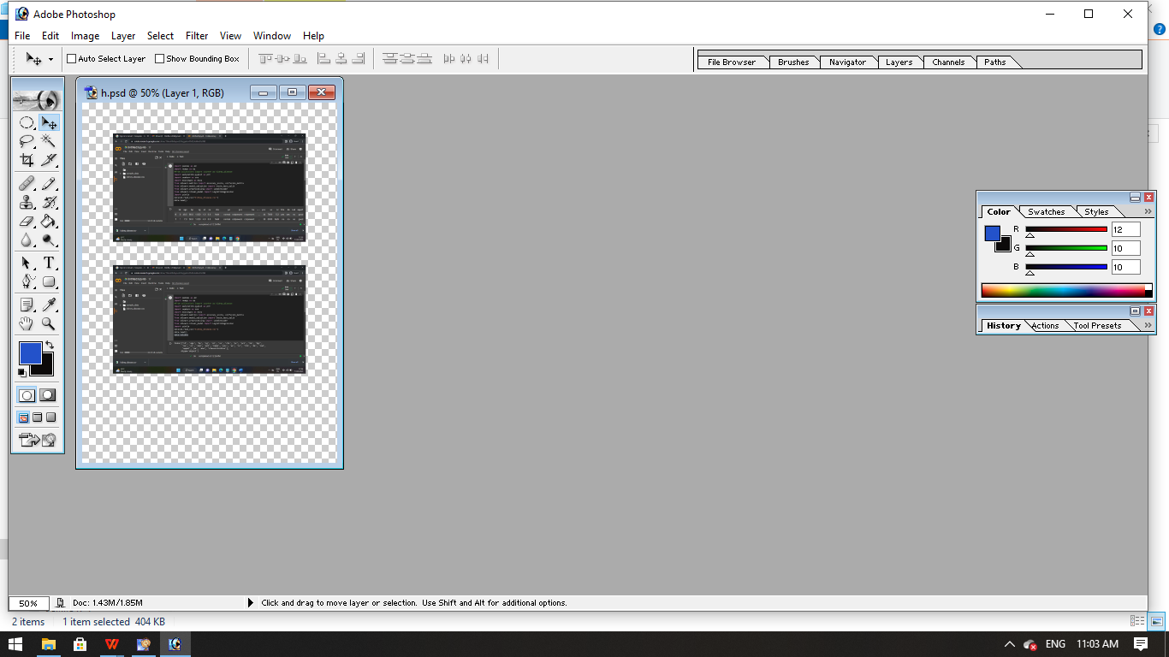

ADVANTAGES & DISADVANTAGES



APPLICATIONS

Predictive analysis using machine learning techniques can be helpful through an early detection of CKD for efficient and timely interventions. In this study, Random Forest (RF), Support Vector Machine (SVM) and Decision Tree (DT) have been used to detect CKD.

CONCLUSION

Lifestyle changes – to help you stay as healthy as possible.

Medicine – to control associated problems, such as high blood pressure and high cholesterol.

Dialysis – treatment to replicate some of the kidney's functions, which may be necessary in advanced CKD.

Kidney transplant – this may also be necessary in advanced CKD.

FUTURE SCOPE

To predict the risk of CKD using machine learning algorithms by analyzing the data of CKD patients. Random Forest and Artificial Neural Network have been used. They have extracted 20 out of 25 features and applied RF and ANN. RF has been identified with the highest accuracy of 97.12%.

APPENDIX

SOURCE CODE

